**Assignment given on 22nd of October**

**Table : Employee**

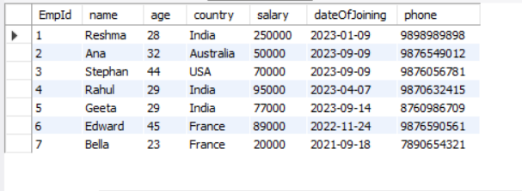

1. Write an SQL  statement to display specific columns such as names and salaries for all Employees
2. Write a SQL query to locate an employee who lives in ‘India'. Return the employee’s name and country.
3. Write an SQL statement to return the name of an employee whose salary is more than 40000.
4. Write a SQL statement to return the name of an employee whose salary is between 50000 and 80000.
5. Write a SQL query to find the employee whose ages are higher than or equal to 30. Order the result by age in descending.
6. Write a query to display the names of employees in the order of their joining date.
7. Write a query to count the number of employees.
8. Write a query to display the name and salary of an employee who either lives in France or Australia.
9. From the following table, write a SQL query to display the name as 'NameOfEmployee'.
10. Write a query to delete the records of Ana.
11. Write an SQL query to find the lowest salary of an employee
12. Write an SQL query to find the highest salary of an employee
13. Write an SQL  query to display the names of employees

       which ends with an ‘a’.

1. Write an SQL query to find the number of employees living in each country.
2. Write a query to find the highest salary of employees in each country having a salary of more than 70000.
3. Write a query to add an email column in the existing employee table.
4. Write a query to update the age of an employee to 55 and salary to 90000 where id is 4.
5. Write a query to rename a column country to address
6. Write a query to delete the age column.
7. Write a query to extract only the first three records from the given table.

**Assignment dated on 4th of November**

A.. Solve the following questions as per the given table.

**Customer**

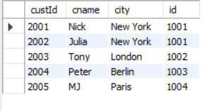

**Salesman**

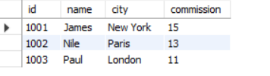

1. Write a sql query to return all of the records from customer table but only matching records from salesperson table using joins.
2. Write a SQL query to find the salesperson and customer who reside in the same city.
3. Write a SQL query to find salespeople who received commissions of more than 11 from the company. Return cname, customer city, name of salesman, commission.

B. Solve the following questions as per the given table

Employee Table

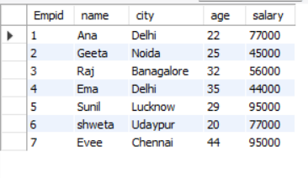

Department Table

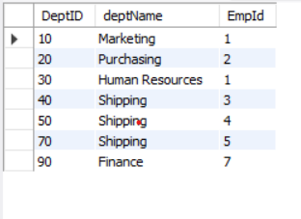

From the above table solve the following

i) Write a query to display the  name of the employee who works in the shipping department

ii) Write a query to display the names of the employees who are not in the shipping department.

iii) Write a query to display the name of a department having employees with a salary less than 50000.

C. Create a table named person with fields id, name, city, age, email, country using the following constraints.

i) The field id should be a primary key

ii) Name field cannot be null

iii) city field cannot be null and for default value use “Delhi”

iv) Age should be greater than 18

v) email should be unique and cannot be null

vi) country field cannot be null and for default use “India”

D. Create a stored procedure named “mytable” and store the query that you used above to create a table “person”.

E. Solve the following questions as per the given table

          Employee table



From the above table write a SQL query to

i) Find the highest salary of an employee

ii) Find the third highest salary of an employee

iii) Find the fourth minimum salary of an employee